

**Document Upload Portal for Medical Records – User Guide**

1. The Provider navigates to <https://documentupload.premiereyecare.net/> or a link is shared with the Provider from a Premier team member via email.
2. Provider logs in to the Portal using the same account information as the Premier Provider Portal:

If user is new to the system, or has any trouble logging in, they can contact Premier using the information shown at the bottom of the login window.

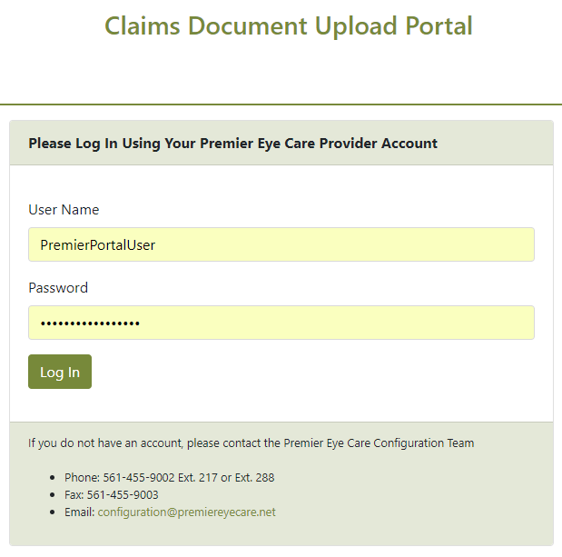

1. Once the Provider has successfully logged in, they may be asked to provide a Claim Number.  
     
   The Provider should input the claim number for which medical records have been requested by Premier.  
     
   If you know that Premier has requested medical records, but you are not sure what the Premier claim number is, please contact Premier and a representative can assist.

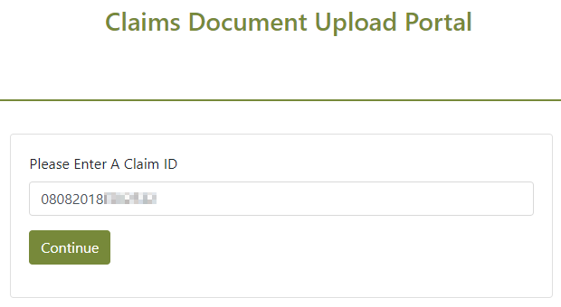

1. After the claim number has been provided, the Provider will see a screen that looks like this.

Each section is described below:

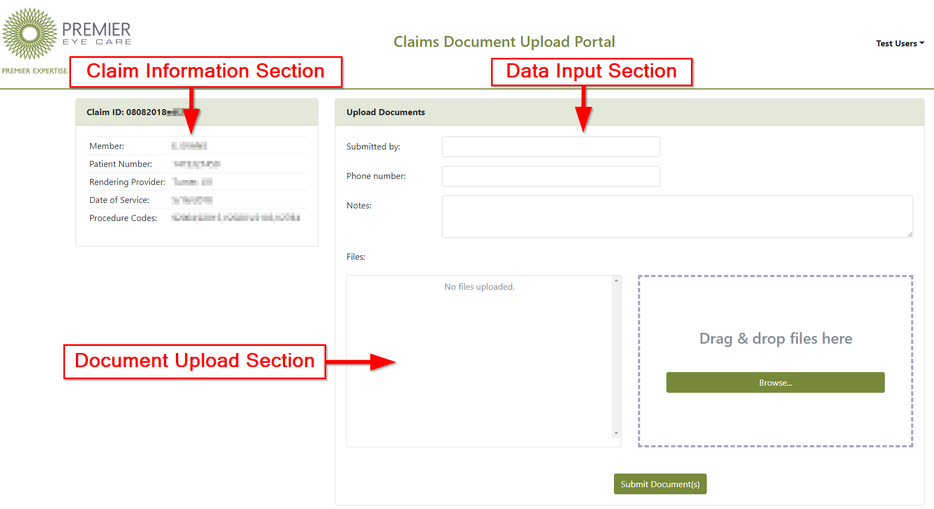

**Claim Information Section**

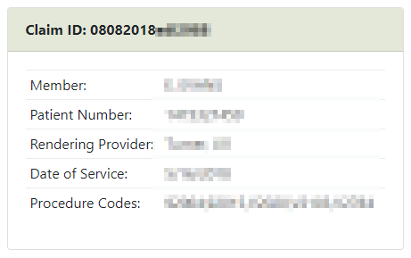

This screen displays information about the claim that Premier has requested documents for.

The Provider should utilize and review this information to ensure they are obtaining and uploading documents for the correct member and service.

If the Provider office uses an EHR system, the “Patient Number” field should match the patient’s ID in that system.

**Data Input Section**



The Provider can provide their information here for Premier to review –

including notes about the documents, contact information, etc.

**Document Upload Section**

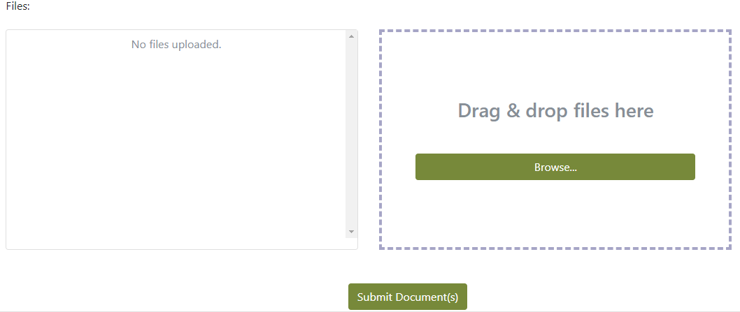

This screen can be used to upload Medical Record documents for the claim.

The Provider can either click and drag files from their computer, or click the “Browse” button to locate them.

Multiple documents can be attached at once. If a document is uploaded by mistake, it can be removed:

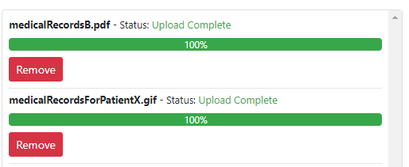

When everything has been filled out and all documents have been uploaded, the Provider can click “Submit Documents” to finally submit everything to Premier and attach the documents to the claim.